Practical - 11
Practical Title: Student Management CRUD with Search and Filter
Create a student management module to add, view, edit, delete, search and filter student records. All database operations must use MYSQLi statements and clear success/failure messages.

Theory
1. Are SELECT, INSERT, UPDATE, and DELETE operations working?
Yes, full CRUD functionality is implemented, allowing data to be dynamically retrieved (SELECT), newly registered (INSERT), modified (UPDATE), and removed (DELETE) from the database.
2. Is search by name/email/course implemented?
Yes, search filtering is active using flexible SQL queries with LIKE operators to instantly filter student records by name, email, or enrolled courses.
3. Are delete operations confirmed before execution?
Yes, destructive operations use JavaScript confirmation dialogs (confirm()) to prompt the user for confirmation before executing the delete command.

Output
- Managed complete student record lifecycles through functional SELECT, INSERT, UPDATE, and DELETE database queries.
- Built dynamic search functionality to query and filter stored records seamlessly by name, email address, or course code.
- Included client-side confirmation pop-ups to prevent accidental data deletion and ensure controlled user actions.

To View Code: https://github.com/shreyajodhani/studenthub.git

Evidence of Work (Screenshots)

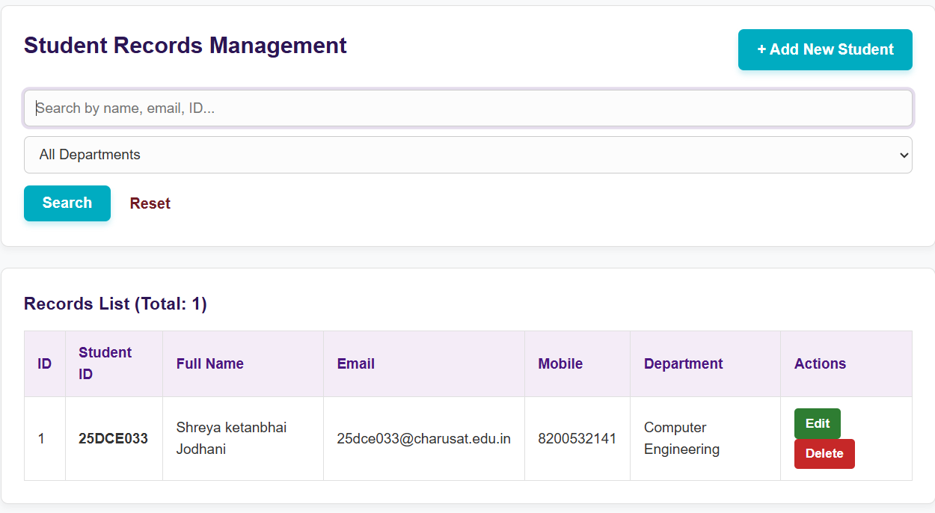
Description: Admin page showing data of student, with options to edit insert and delete.

GitHub Repository Link: https://github.com/shreyajodhani/studenthub.git

Challenges Faced:

To implement schema for operations

Learning Outcomes:
Learn CRUD operations.
Faculty Remarks: (Keep this blank for faculty)

